Computer Network lab
Name: Ayush Ravindra Patil
Date: 27-08-26
Practical: 1

1] Bit Stuffing

Code:
def bit_stuffing(data):
flag = '01111110'
pattern = '111111'
stuffed_bit='0'
stuffed_data = ''
count=0
for bit in data:
if bit=='1':
count_ones += 1
stuffed_data += bit
else:
count_ones = 0
stuffed_data += bit
if count_ones == 5:
stuffed_data += stuffed_bit
count_ones = 0
return flag + stuffed_data + flag

data = '01111011111101110'
print(f'Original data: {data}')
print(f'stuffed bit: {bit_stuffing(data)}')

Output:
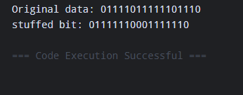

2] Character Stuffing

Code:
def character_stuffing(data):
flag = 'F'
esc = 'E'
stuffed_data = ''
for char in data:
if char == flag or char == esc:
stuffed_data += esc
stuffed_data += char
return flag + stuffed_data + flag

data=input("Enter character frame: ")
print(f'Original Data: {data}')
print(f'Stuffed Data: {character_stuffing(data)}')

Output:
